|  |  |
| --- | --- |
| Date | 18 Nov 2022 |
| Team ID | PNT2022TMID47995 |
| Project Name | Smart Fashion Recommender Application |
| Team members | A.Ajitha  G.Pooja  M.Reka  P.Vaishali |

Sendgrid Open Page:



Sendgrid login Page:

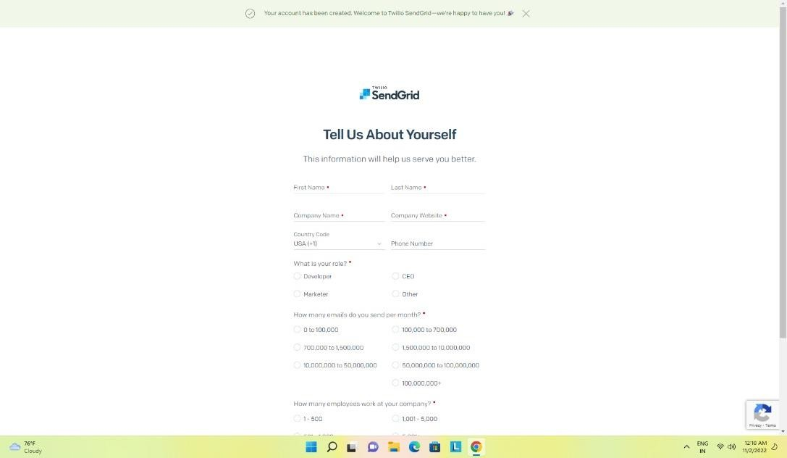

Sendgrid successfully created:

